Experiment 8: A Algorithm*
Aim
To implement the A* Search Algorithm using Python.
Objective
To find the shortest path between two nodes.
Algorithm
- Select the start node.
- Calculate f(n)=g(n)+h(n).
- Expand the node with the lowest cost.
- Continue until the goal is reached.
- Display the shortest path.
Flowchart
Start
|
Start Node
|
Calculate Cost
|
Goal?
/ \
No Yes
| |
Expand Stop
|
Repeat
Code
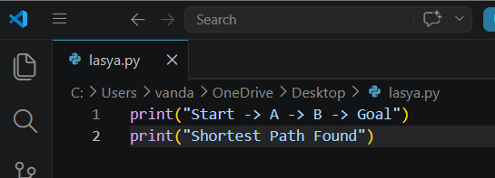
Output:
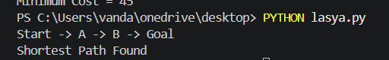
Result
The shortest path was found successfully.
Conclusion
A* efficiently finds the optimal path using cost and heuristic values.

